http://users.sch.gr/aiasgr/Image/Naoi_kai_Mones/O_Naos_tou_Solomwnta/O_Naos_tou_Solomwnta_02.jpg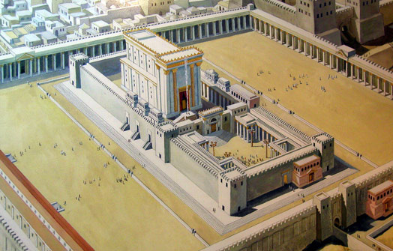

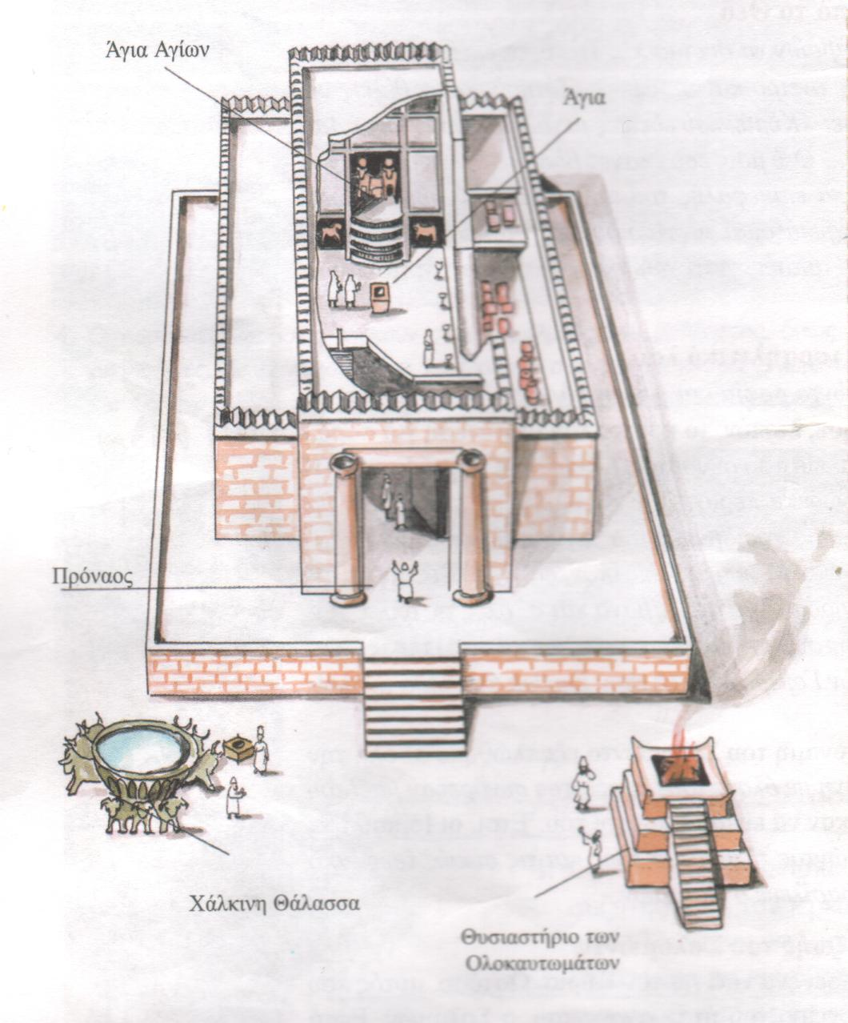

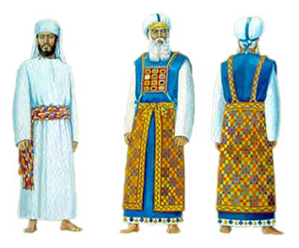
http://users.sch.gr/aiasgr/Biblos/Biblos/Oi_takseis_twn_ierewn.htm

