

Applied Linguistics to Foreign Language Teaching and Learning
Unit 7: Focus on Learning and the Language Learner
Evdokia Karavas
School of Philosophy
Faculty of English Language and Literature

Contents
1. Learning and learner differences 3
1.1 Variables affecting learning outcome 3
1.1.1 Affective variables (related to emotions and feelings) 3
1.1.2 Personality variables (related to personality traits) 4
1.1.3 Socialization variables (related to how one works with others) 4
1.1.4 Cognitive variables (related to mental processes) 4
1.2 Learning strategies 4
2. Facilitating learning 6
3. Autonomy and self-direction in Foreign Language Teaching/Learning 7
3.1 Arguments for developing learner autonomy 8
4. References 9
Appendix 1 10
Appendix 2 11
Appendix 3 13
Appendix 4 15

Learning and learner differences
Teaching does not necessarily result to learning, and learning is not necessarily a result of teaching –‘good’ or ‘bad’. In fact, we all learn things even if no one teaches them to us. Of course, it is also true that teaching may help us learn, especially if we feel that what we are learning is of some use to us in the long run (though not necessarily of instrumental use), and we somehow enjoy the pedagogic process or feel that it responds to our expectations of what teaching should be.
All this is common knowledge just as it is fairly evident to most of us that learning is not equivalent to storing in our mind facts and dates. Learning something entails much more. And, of course learning a language is not equivalent to storing in our memory rules of grammar and vocabulary.
Task 1:
Think about what it means to learn something in our everyday social life and what it means to learn something as part of our educational experience in school or at university. Are there many differences? Then, think about what we mean when we say that someone (a) has learned a language, (b) is a ‘good’ language learner.

1.1 Variables affecting learning outcome
If learning does not depend exclusively or mainly on good teaching, what does it depend on?
Task 2:
Think about the following questions, answer them and then consult Table 1 below to check your answer:
- Does learning depend on whether we are interested or disinterested in the object of knowledge?
- Does it depend on whether we find it easy or difficult?
- Does it depend on whether we have developed strategies to cope with the particular subject matter?
- Does it depend on whether we have developed strategies to cope with what is required in school?
Learning actually depends on all of the above and much more. These are only some of the factors involved. As we attempt to understand the very complicated issue of how learning occurs or how teaching can facilitate learning, we should take into account the various variables that affect learning. These are listed in the below.

Affective variables (related to emotions and feelings)
Motivation:
- Instrumental and integrative motivation.
- Extrinsic and intrinsic motivation.
Attitudes:
- towards the target language and culture.
- towards the users of the language.

Personality variables (related to personality traits)
Psychological profile Introversion or extroversion (in order to enter into conversation, to role play, etc.):
- Feeling comfortable or uncomfortable with new ideas and ways of doing things.
- Feeling comfortable or uncomfortable with experimentation and open-ended questions.
- Socialization Variables (related to how one works with others).

Socialization variables (related to how one works with others)
- Group membership: Working as a member of a group.
- Leadership qualities: Taking initiatives.

Cognitive variables (related to mental processes)
- Cognitive skills: Skills to memorize, to deduce/induce meaning, to analyze/synthesize/evaluate information, to distinguish between fact from opinion, cause from effect, etc.
- Learning and communication strategies: Learning strategies relate to input (taking in messages from others).
- Communication strategies relate to output (how we deliver messages to others). Note: Sometimes communication strategies can function as learning strategies.

1.2 Learning strategies
Oxford (1990) has developed an elaborate classification system of learning strategies. She defines learning strategies as “specific actions taken by the learner to make learning easier, faster, more enjoyable, more self-directed, more effective and more transferable to new situations”. Moreover, she distinguishes between direct and indirect strategies.
Task 3:
Read the definition of direct and indirect strategy types in Table 1 and try to match them with six learning strategies in Table 2.
Table 1: Types of learning strategies
DIRECT STRATEGIES  to work with the language itself | INDIRECT STRATEGIES  to manage learning in general
Memory strategies  They are used for remembering and retrieving new information. | Metacognitive strategies  They are used for coordinating the learning process.
Cognitive strategies  They are used for understanding and producing the language. | Affective strategies  They are used for regulating emotions.
Compensation strategies  They are employed when using the language despite knowledge gaps. | Social strategies  They are employed when communic-ating and learning with others.

‘Good’ learners employ a variety of strategies for effective language learning. Here are some of them.
Table 2: Six learning strategies to employ
- Taking risks wisely: Pushing yourself to take risks in a language-learning situation, even though there is a chance of making a mistake or looking foolish. Risks must be tempered with good judgment.
- Remembering new language information according to its sound: One example is a way of learning FL vocabulary. You think of a word in your LI (or any other language) which sounds like the word you are trying to learn. You try to associate the two words. For example, if you are trying to learn the Russian word brat (meaning 'brother'), you could associate it with the English word brat (an 'annoying person'). Bringing to mind this association may help you remember the Russian word. Another way often used is by using rhymes to remember a word (rat - cat).
- Finding out about language learning: Making efforts to find out how language learning works by reading books and talking with other people, and then using this information to help improve one's own language learning'.
- Cooperating with peers: Working with other language learners to improve language skills. This strategy can involve a regular learning partner or a temporary pair or small group. This strategy frequently involves controlling impulses toward competitiveness and rivalry.
- Switching to the mother tongue: Using the mother tongue for an expression without translating it, as in Ich bin eine girl [used when a native speaker of English learning German cannot remember the German word for 'girl']. This strategy may also include adding word endings from the new language onto words from the mother tongue.
- Repeating: Saying or doing something over and over: listening to something several times; rehearsing; imitating a native speaker.
Task 4:
At the beginning of this Unit you identified some characteristics of good language learners based on your personal experience. Compare your suggestions on the characteristics of good language learners with the ones identified by research studies below.
Seven hypotheses about good language learners:
- The good language learner is a willing and accurate guesser.
- The good language learner has a strong drive to communicate, or to learn from communication. S/he is willing to do many things to get his message across.
- The good language learner is often not inhibited. S/he is willing:
  - to appear foolish if communication requires it,
  - to make mistakes in order to learn to communicate,
  - to live with a certain amount of vagueness.
- In addition to focusing on communication the good language learner is prepared to attend to form as well as meaning and appropriate use. S/he is constantly looking for patterns in the language.
- The good language learner practices on his or her own.
- The good language learner monitors his/herself and the speech of others. That is, s/he is constantly attending to how well his/her speech is being received and whether his/her performance meets the standards s/he has learned.
- The good language learner attends to meaning. S/he knows that in order to understand the message it is not sufficient to pay attention to the language or to the surface form of speech as well as to what is said or remains unsaid.
Task 5 :
Think back to your experiences as language learners and try to remember cases of ‘good’ and ‘bad’ language learners that were in the same class as you. What was it that made you think they were ‘good’ or ‘bad’ at learning English? List the characteristics of good language learners.

Facilitating learning
Is it possible to facilitate learning by intervening so that a teacher may contribute positively to altering negative factors involved in learning? Yes it is. In fact, that is what all interested teachers seek to do whether they realize it or not. Here are some ideas.
Techniques for increasing/sustaining motivation:
- Providing sufficient variety of input (listening and reading), of interaction and of activity to allow students to work in their own style and with their own strategies.
- Providing learners with a real purpose to communicate (speaking/writing).
- Showing awareness of differences in motivation, in emotional responses, in strategies etc., encouraging students to build awareness of their own preferences.
- Providing tasks which are challenging and related to learner needs. Tasks with achievable goals so that students can enjoy some measure of success and satisfaction.
- Creating a supportive classroom environment where students feel comfortable to make mistakes and take risks.
Techniques for developing learners’ cognitive skills:
The development of cognitive skills is dependent on the functions of the brain and the way the brain functions depends on a variety of factors which are both biological (e.g., age) and social (e.g. amount and quality of input from the social environment). FL learners’ cognitive skills are already developed when they come to a foreign language course, though groups of learners and individuals exhibit differential cognitive development and skills. These can be further developed through a variety of techniques and task types.
Task 6:
Look at the activities in Appendix 1 and decide what types of cognitive skills are involved in carrying out these activities successfully.
Techniques for developing learning strategies:
In order to help learners develop the direct and indirect strategies in Table 2, teachers may use a variety of techniques.

Task 7:
Study the activities in Appendix 2. Explain if the tasks help learners develop any of the strategies described in Table 3.
Table 3: Helping learners develop language learning strategies.
Strategies | Description
Memory | - Creating mental linkages.  - Applying images and sounds.  - Reviewing well.  - Employing action.
Cognitive strategies | - Practicing.  - Receiving/sending messages.  - Analysing and reasoning.  - Structuring input/ output.
Compensation strategies | - Guessing intelligently.  - Overcoming limitation in.  - speaking and writing.
Meta-cognitive strategies | - Centering learning.  - Arranging / planning learning.  - Evaluating learning.
Affective strategies | - Lowering anxiety.  - Encouraging yourself.  - Taking emotional temperature.
Social strategies | - Asking questions.  - Cooperating with others.  - Empathising with others.

The main reasons for learner strategy training are:
- It contributes to the main goal of the development of communicative competence.
- It helps learners to become more self-directed.
- It helps learners think in a problem-oriented fashion.
- It facilitates the development of the person as a whole.
- It helps them become conscious of the strategies they have already developed and those they have not.

Autonomy and self-direction in Foreign Language Teaching/Learning
If we are to continue learning all our lives, as we should, rather than to stop learning when we leave school or university, we should develop the attitude, ability and skills required for what we call ‘autonomous’ learning. But what is that? How do we define the notion?

Task 8
Do you think that “autonomous learning” differs from “self-access” or “self-directed learning”? How?

3.1 Arguments for developing learner autonomy
Ethical: The individual has the right to exercise his/her choices in learning and not to passively accept choices made by social institutions. One of the main aims of education is to help individuals to develop positive attitudes towards lifelong learning and to acquire skills for self-study.
Economic: Society does not have the resources to provide individualized instruction in every area of learning for each individual. Therefore, individuals must identify their own learning needs and seek out opportunities for learning (individually or cooperatively).
Psychological: This argument draws support from cognitive psychology which maintains that learning is a process of problem solving and that learning is more meaningful and permanent when it is directly related to learner needs and when learners are actively involved in the learning process.
Good language learners have been found to:
- find their own way, taking charge of their learning,
- organize information about language,
- make their own opportunities for practice in using the language inside and outside the classroom.
Task 9
Share your thoughts with the colleague sitting next to you. Decide in what ways and in what areas the two of you are autonomous learners and what kind of autonomous learning techniques you use.
Task 10
Look at the activities of Appendix 3. Decide which of them foster the idea of autonomous learning and explain why.
Mini project
Appendix 4 contains an amended activity suggested by Hedge (2000, pp. 40-41), asking you to look at the list below –a list of “hopes” about the roles and responsibilities of EFL teachers and learners. Revise and add to this list your own realistic hopes, as these are shaped by the Greek social and educational context as well as your own experiences as learners and as teacher-trainees.

References
Hedge, T. (2000). Oxford Handbooks for Language Teachers, Oxford University Press.
Naiman, N. (1978). The Good Language Learner. Research in Education Series No. 7.
Nunan, D., & Lamb, C. (1996). The self-directed teacher: Managing the learning process. Cambridge University Press.
Rubin, J. (1975). What the" good language learner" can teach us. TESOL quarterly, 41-51.
Willis, J. W. (1996). Technology, Reading, and Language Arts. Allyn & Bacon, Order Processing, PO Box 11071, Des Moines, IA 50336-1071.

Appendix 1

Communication Task 1: Work in pairs. Study the picture and decide what the woman is going to do. Tell your partner. Begin like this: “I bet she’s going to……” Your partner should react in any way s/he thinks suitable, agreeing or disagreeing with you. Then change roles.
Communication Task 2
Look at what good old movies are playing this week. Decide on two that you’d like to see and explain why.
Weekly film guide

All that Jazz is an x rated quality film that also made it as a box hit. In this dazzling musical directed by Bob Fosse, Roy Schneider's seductive performance is impressive.
Atlantic City an AA rated film directed by Louis Malle. It's an amiable semi-gangster movie in which Burt Lancaster, as underworld hanger-on, gives a fine, quiet performance.
Being There an AA rated film where Peter Sellers is at his best. The movie, a tragicomedy with heavy strokes of ironical British humor, is about a simple-minded gardener taken by classy American society as a political genius.
The Blue Lagoon is an AA rated film with the adolescent star, crowned with popularity, Brooke Shields. The movie, a romantic story for a quiet evening, is about two children growing to sexual maturity in isolation on a Pacific Island.
Stardust Memories is a film in which Woody Allen gives biographical entertainment; relations with girl, reaction to conventional fans. He is, once again, Woody Alien: quality psychoanalysis filmed in Hollywood.
Tootsie is Sidney Pollak's AA rated film with Dustin Hoffman and Jessica Lang who got an Oscar award as supporting actress This American comedy is about an actor who's failed and becomes an actress in order to succeed as a star.

Appendix 2
(From: Task Way English 3)
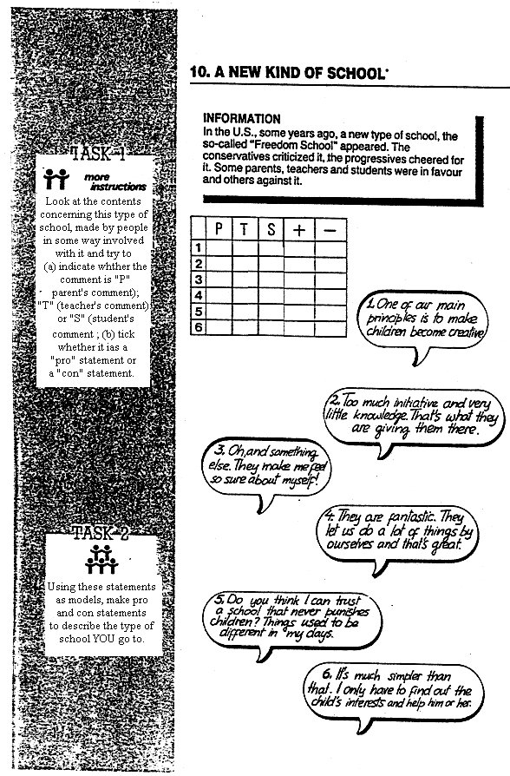

(From: Task Way English 3)


\

Appendix 3
(From: Natural English, O.U.P. 2002)
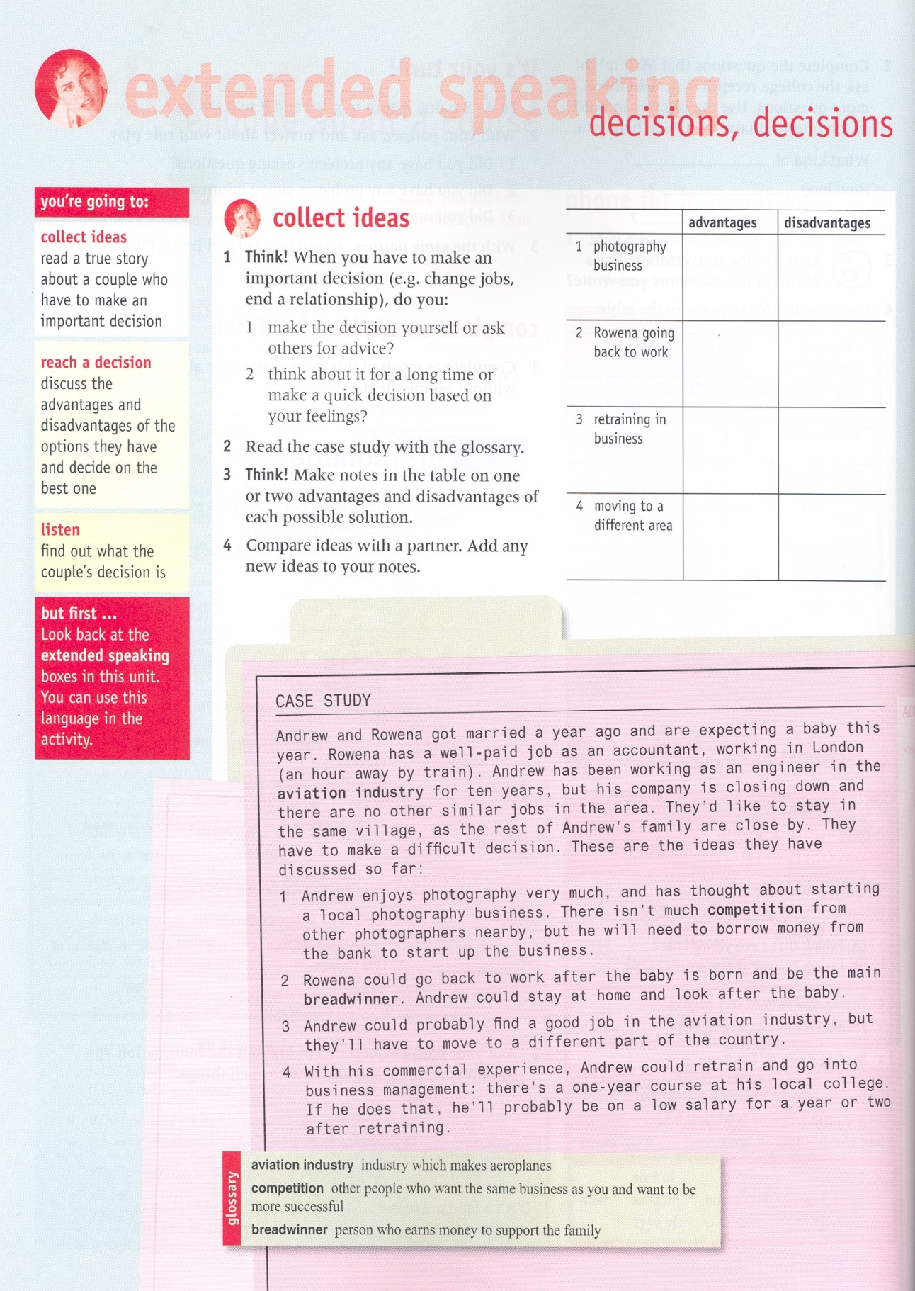

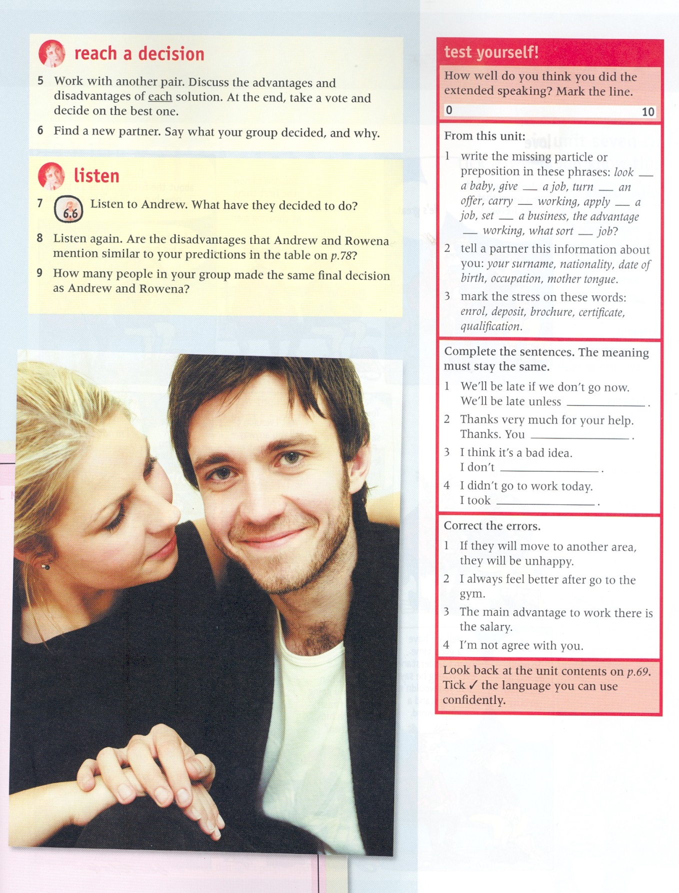

Appendix 4
What teacher-trainees hope for in a Greek EFL classroom
Students
1 | We hope to find the students involved in what they are doing, contributing to it and getting satisfaction from it on both a personal level and a social level. | That is to say, I hope not to find them on concentrating merely on coming up with the correct answers or on grinding out correct sentences and free conversations for the sake of the lesson.
2 | We hope to find students comfortable and relaxed, even when they are in the midst of intense study activity and rigorous interaction | This does not mean that they are loafing in the classroom, since students who feel comfortable are less likely to loaf. Also, it does not mean that they are afraid of being punished in some way or other if they do not meet the teacher’s expectations.
3 | We hope to find students listening to one another, and not just to the teacher, helping and correcting each other. | This means that students do not expect all knowledge and support from the teacher but that they recognize their own contribution to their learning process and that of their fellow students.
4
Teachers
5 | We hope that the teacher is in control of what is going on in her/his class. | This does not mean that everything the students do comes as a direct response to a specific cue from the teacher.
6 | We hope that the teacher allows/ encourages / requires students to respond on the basis of their own experiences, whether they are producing an utterance or performing a communicative activity. Also, we hope that the teacher makes appropriate choices among a range of techniques. | This does not mean that they are not given guidance with regard to what to say and especially how to say it.
7 | We hope that the teacher seems relaxed and but firm in voice and manner, giving information about the appropriateness or correctness of what the students do rather than criticizing or praising them. | That is, I hope the teacher does not directly or indirectly say to students things like: “Now remember…” “You should always…” “You are a failure / very successful in what you do…” “ Do this so that I may judge you on it…”
8
The classroom and school facilities
9
10
The teaching-learning materials and aids
11
12

Notes
Note on History of Published Versions:
The present work is the edition 1.0.
Reference Note:
Copyright National and Kapodistrian University of Athens, Evdokia Karavas. Evdokia Karavas. “Applied Linguistics to Foreign Language Teaching and Learning. Focus on Learning and the Language Learner”. Edition: 1.0. Athens 2014. Available at the Applied Linguistics to Foreign Language Teaching and Learning Open Online Course.
Licensing Note:
The current material is available under the Creative Commons Attribution-NonCommercial-ShareAlike 4.0 International license or later International Edition. The individual works of third parties are excluded, e.g. photographs, diagrams etc. They are contained therein and covered under their conditions of use in the section «Use of Third Parties Work Note».

[1] http://creativecommons.org/licenses/by-nc-sa/4.0/
As Non-Commercial is defined the use that:
- Does not involve direct or indirect financial benefits from the use of the work for the distributor of the work and the license holder.
- Does not include financial transaction as a condition for the use or access to the work.
- Does not confer to the distributor and license holder of the work indirect financial benefit (e.g. advertisements) from the viewing of the work on website.
The copyright holder may give to the license holder a separate license to use the work for commercial use, if requested.
Preservation Notices:
Any reproduction or adaptation of the material should include:
- the Reference Note,
- the Licensing Note,
- the declaration of Notices Preservation,
- the Use of Third Parties Work Note (if available)
together with the accompanied URLs.

Financing
- The present educational material has been developed as part of the educational work of the instructor.
- The project “Open Academic Courses of the University of Athens” has only financed the reform of the educational material.
- The project is implemented under the operational program “Education and Lifelong Learning” and funded by the European Union (European Social Fund) and National Resources.



From: Rubin 1975, adapted by Naiman et al. 1978.
Based on Hedge (2000), Willis (1996), Nunan and Lamb (1996).

