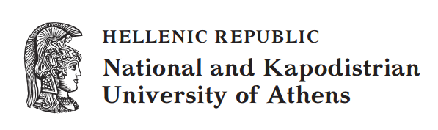

Applied Linguistics to Foreign Language Teaching and Learning
Unit 3: The Object of Knowledge in Foreign Language Courses
Bessie Dendrinos
School of Philosophy
Faculty of English Language and Literature

Contents
1. Different views about what the object of knowledge is in FL courses 3
1.1 Structural view of language 3
1.2 Functional view of language 3
2. Organizing the object of knowledge for foreign language teaching and learning 4
3. Views about language and language teaching 5
4. Trends in Linguistics and their impact in FLD 6
4.1 The Formalist or Structuralist trend in Linguistics 6
4.2 The Functionalist trend in Linguistics 6
4.3 The impact of the two trends in FLD 7
Appendix 1A 8
Appendix 1B 9

Different views about what the object of knowledge is in FL courses
The object of knowledge in a language course is the content of a syllabus that traditionally includes a selection of language, which is sequenced into a teaching order. For the purposes of selecting language, however, one requires something to select from. This something has to be a list of categories, which usually derives from a view of language, some way of describing it.

1.1 Structural view of language
A structural view of language usually results in formal grammatical descriptions that many people are familiar with because of their experience in traditional language education. Such descriptions permit the listing of structural or grammatical categories, such as: the past or future tense, the definite and the indefinite article, passive voice. Structural views of language also result in phonetic descriptions that permit the listing of phonemes and other suprasegmental features, or in vocabulary syllabi that include lists of lexical items.

1.2 Functional view of language
Some functional views of language that entail describing language from a semantic and pragmatic perspective, resulted in the so-called Functional-Notional syllabus, which contains categories of language functions and notions, rather than lists of the formal properties of language. In other words, the categories selected for teaching/ learning purposes is organised in terms of meaning and use, rather than the form of the language.
Therefore, the syllabus is organised in terms of notions (meaning). For instance:
- Notions of time: Points of clock time, or points in the day such as noon and midnight; Division of time, such as day of the week, month, year, season, weekend, holiday; Priority and sequence in time, such as anteriority/posteriority before+NP, after+NP, later (on); Past reference, e.g. Past simple, past expressed with "used to", yesterday, last week/month/year, (three) days/months/years ago; Frequency, etc.
- Notions of quantity: Quantity of goods; Comparisons with comparative and superlative degrees of adjectives and adverbs; etc.
It is also organised in terms of the social use of language, i.e., its communicative functions. For instance, there are categories in the syllabus such as:
- Apologising,
- Greeting people;
- Giving directions;
- Giving instructions;
- Inviting; Warning;
- Seeking permission.
The language categories, whatever they may be, grammatical, notional/functional, etc. organised and sequenced in a particular order, make up the syllabus. This is diagrammatically presented in Figure 1 below:

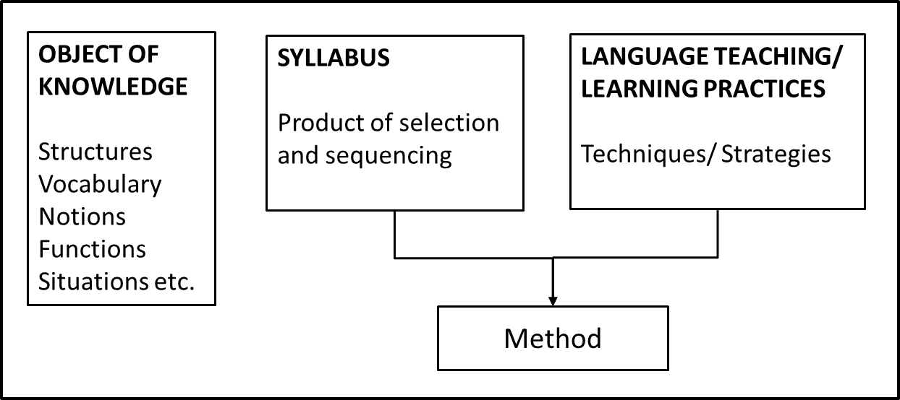
Figure 1: Language categories and the syllabus.
Therefore, grammatical-structural, or notional/functional, etc. are labels to apply to syllabus and not to approach or method.
Task 1:
Does drawing up lists from one way of categorizing language mean that the course planner is prevented from drawing up lists from another type of language categorization? For example, does it mean that a grammatical syllabus will not also deal with phonemes or that it will not also contain vocabulary as well as functions of language? Look at Appendix 1A and 1B, where you will find the Table of contents of two EFL coursebooks (a kind of syllabus proposed by the coursebook writers) and answer the question.

Organizing the object of knowledge for foreign language teaching and learning
In practice, course planners and coursebook writers have found ways to make notions/functions coexist with structures for reasons that have to do with a variety of factors, many of which have nothing to do with theoretically informed views of language. Grammar is popular with parents but also teachers, and easy for them too –particularly for those untrained to teach anything else but the most obvious and observable elements of language. Therefore, the uninformed attempts have produced peculiar and comic results, as planners and coursebooks writers have sometimes, for example, gone to great lengths to combine traditional grammatical categories with notions and functions or to list endless utterances which are the manifestations of a language function, such as that of: Making requests. The list may include anything from: Please close the door to I’d be most frightfully grateful if you would please close the door, if you don’t mind.
Of course, this is not the point. The idea is that, if the course planner and/or coursebook writer is interested, for example, in form, meaning and use as interrelated, to resort to views of language that allow such a description, and therefore the development of appropriate categories for teaching/learning purposes.
Task 2:
Use the knowledge you have developed so far in your Linguistics courses and think about what theory of language may be more conducive to teaching language as form + meaning + use (as interrelated).
Of course, the choice of language content for the course (or coursebook) syllabus is also contingent upon the approach to language teaching/learning that the course planner follows, which is relevant to the underlying view and theory of language.

Views about language and language teaching
Distinctly different views about language, as mentioned in a previous Unit, have generated different theories of language study and analysis, which have had an essential impact in FLD.
Task 3:
Some of these views are presented in Table 1 below. Note that, whereas all the views above provide an answer (though a distinctly different one) to the question “What is language?”, only some of them provide an answer to the question “What is language for?” Read them and decide which ones.
Table 1: Views of Language
View of language | Explanation
System | It is a highly ordered system of patterns and units of expression tied to patterns and units of content that are used to convey or create meanings. [Therefore, language is a semiotic system – a system of arbitrary or socially situated signs.]
Object | It is valued object of knowledge that one has the innate capacity of acquiring.
Phenomenon | It is a cognitive phenomenon tightly linked to the operations of the mind.
Social action | We use language to perform various social acts or functions, such as to apologise, order or convict, make a request or give instructions. In this sense, language is a social action.
Instrument | It is a tool for the communication of ideas and feelings, for the exchange of information and for the development of relationships.
Product | Language is one type of behaviour and language production requires a set of skills developed through habit formation.
Process (Practice) | Language is social practice enacting social operations through which meaning is derived.
Task 4:
Depending on whether the concern of foreign language programme planners is focused on What language is for rather than What language is, the object of knowledge to be taught and learnt will be different and, of course, so will the approach to teaching and learning. Think about why.

4. Trends in Linguistics and their impact in FLD
There are two general trends that have dominated 20th century Linguistics.

4.1 The Formalist or Structuralist trend in Linguistics
The Formalist or Structuralist trend includes all those views representing language as an autonomous meaning system, not dependent on language use. The linguistic sign is considered to be arbitrary, i.e., not socially situated. That is why this kind of Linguistics is often referred to as Autonomous. It has primarily been interested in the formal properties of language –the linguistic form of words (their pronunciation and morphological structure), parts of speech (as described by formal grammar, such as adjectives, verbs and pronouns) and in the structure of clauses and sentences, where words are combined in ways which are specific to each language to express meaning that corresponds with some objective reality.
Understanding that language is a rule-governed system and that there are rules of linguistic form, the study of language in Autonomous Linguistics has aimed at analysis which allows the description of its phonological, morphological, syntactic and semantic structure, independently from social context. This has resulted in the structural syllabi that were mentioned in Section 2 of this Unit. Information from phomemic and suprasegmental analysis, as well as formal semantic, morphological and syntactic analysis at word and sentence level have been the basis for categories based on the description of the formal properties of language –categories from which the structural syllabus draws.
Task 5:
Think about and say what kind of language categories a structural syllabus may legitimately draw from and what not.

4.2 The Functionalist trend in Linguistics
The theoretical assumption behind Functionalist theories of language, particularly those that view language as a social semiotic system (understanding the sign as socially situated), is that language co-evolves with culture as it is produced and reproduced through its social institutions, shaping and shaped by discourses that are articulated as text. In other words, language is the material configuration of discourse as text. This means, on the one hand, that meaning is always socially construed and, on the other, that linguistic structure is dependent on social structure (and vice-versa). Therefore, the lexicogrammar of language encodes, reproduces and has the potential of changing social meanings.
Such a conception of language (understood as social practice, whereby “ways of saying are ways of (socially situated) meaning”), has stimulated interesting theory and practice in language education and literacy studies, especially in Australia, and has also been at the root of the field of Educational Linguistics.
European FLD has not, until now, benefited substantially from this way of thinking about language, though it has informed the work that is being carried out in Greece by Bessie Dendrinos. However, there is indeed a version of Functionalist thinking behind purely notional/functional syllabi whose popularity was short-lived. But, the idea of introducing the functional use of language did not evaporate. It was blended with structuralist thinking, producing the so-called ‘eclectic’ syllabus, which from a theoretically informed view could be critiqued as a mish-mash, a ‘pot-pourri’ of language categories for language teaching purposes.

4.3 The impact of the two trends in FLD
The two trends in Linguistics discussed above, along with particular views about language learning to be examined in later Units, have led or are attempting to lead to different ways not only of planning and organizing course content i.e., the object of knowledge but also, as will be explained in later Units, to different instructional materials, classroom practices and planning of the pedagogic process.
Task 6:
With the information you have so far, think about which of the two trends has led to foreign language courses that do what is stated in column 1. Tick column 2 for Formalism and 3 for Functionalism.
Foreign language courses that: | Formalism | Functionalism
Emphasise the teaching/learning of formal grammar and syntax, vocabulary and pronunciation in linguistic but not social context.
Emphasise the teaching/learning of language use, i.e., the properties of language (its grammar, vocabulary, intonation of utterances, etc.) in communicative contexts.
Organise and sequence language categories in terms of structural complexity, i.e. from what is perceived as easy for the learner to what is thought to be more difficult.
Organise and sequence language categories in terms of their use in situational contexts that are thought to be useful for the learner.
Emphasise practice of words and language patterns in isolation, so students can learn the meaning of words and the way grammar works in sentences.
Emphasise practice of language in the context of authentic or authentic-like discourse and text or in the context of different social situations.
Use instructional materials with reading texts and dialogues to display linguistic knowledge, i.e., to illustrate how language operates in a linguistic context (at the level of the sentence).
Use instructional materials that contain authentic and authentic-like texts, which constitute instances of language use to create social meanings and show how language operates in a social context (at the level of text).

Task 7:
Can you think of any other ways that the two linguistic trends have affected knowledge (course content) selection knowledge - in other words, the WHAT of language teaching and learning.

Appendix 1A
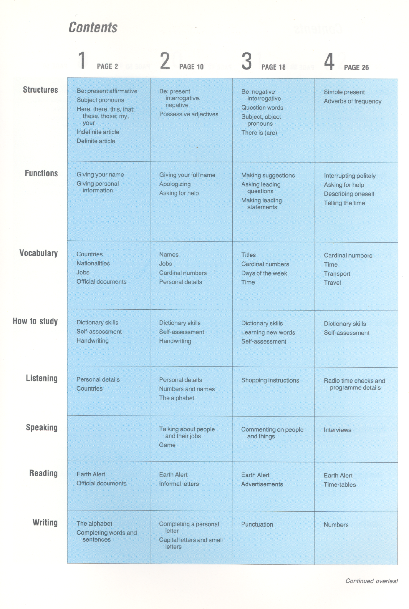
Figure 2

Appendix 1B
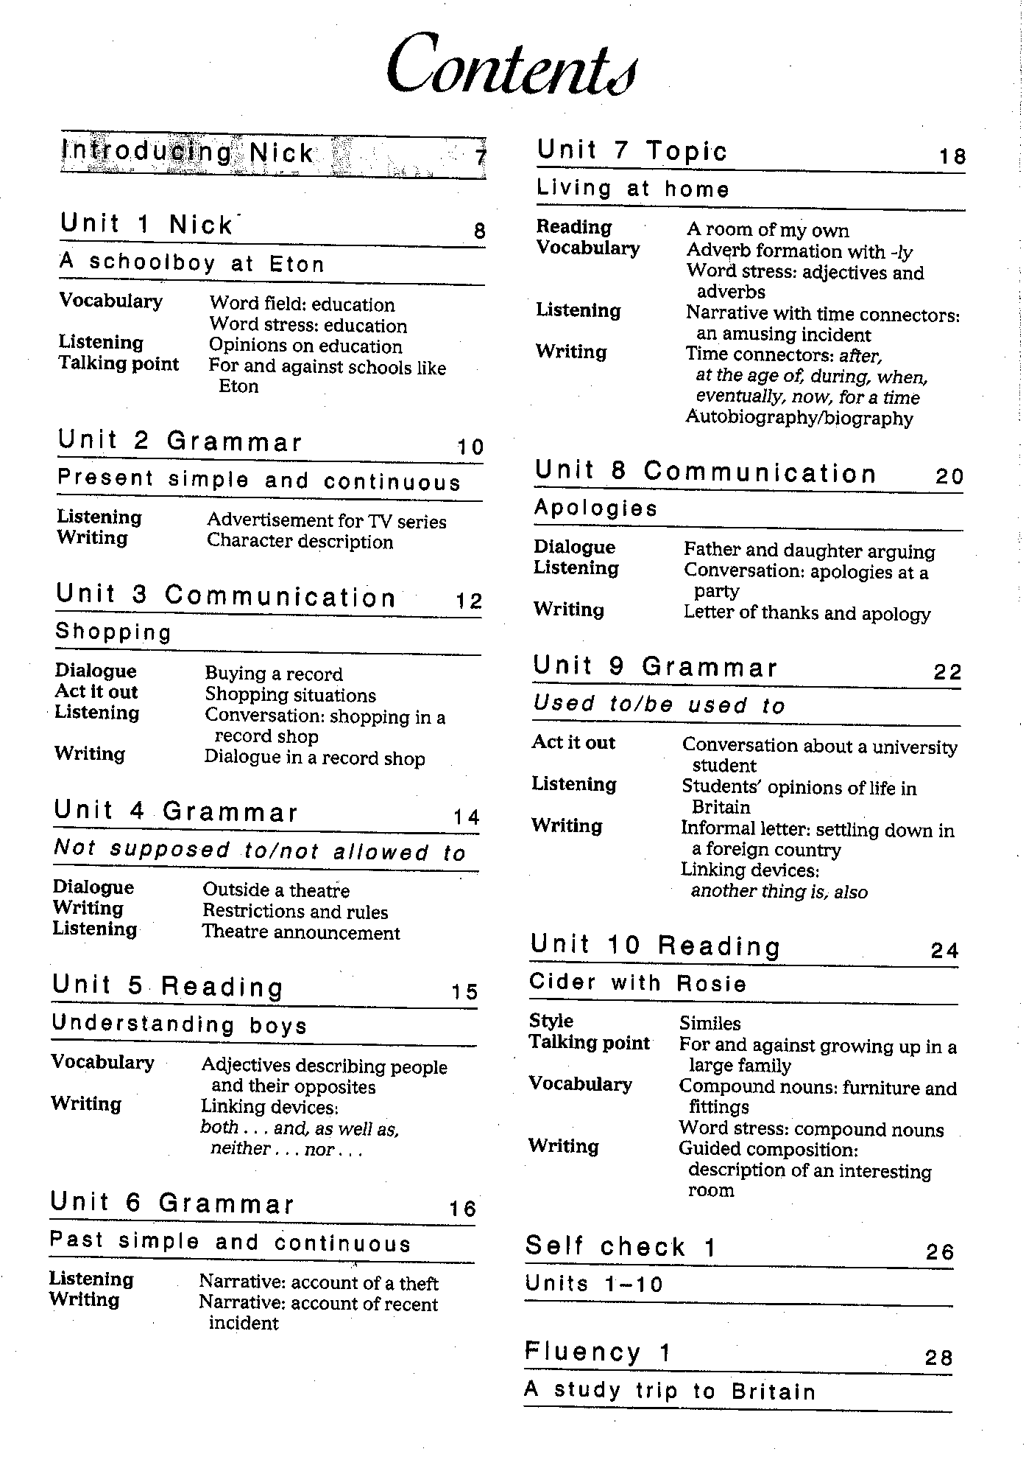
Figure 3
Notes
Note on History of Published Versions:
The present work is the edition 1.0.
Reference Note:
Copyright National and Kapodistrian University of Athens, Bessie Dendrinos. Bessie Dendrinos. “Applied Linguistics to Foreign Language Teaching and Learning. The Object of Knowledge in Foreign Language Courses”. Edition: 1.0. Athens 2014. Available at: http://opencourses.uoa.gr/courses/ENL6/.
Licensing Note:
The current material is available under the Creative Commons Attribution-NonCommercial-ShareAlike 4.0 International license or later International Edition. The individual works of third parties are excluded, e.g. photographs, diagrams etc. They are contained therein and covered under their conditions of use in the section «Use of Third Parties Work Note».
[1] http://creativecommons.org/licenses/by-nc-sa/4.0/
As Non-Commercial is defined the use that:
- Does not involve direct or indirect financial benefits from the use of the work for the distributor of the work and the license holder.
- Does not include financial transaction as a condition for the use or access to the work.
- Does not confer to the distributor and license holder of the work indirect financial benefit (e.g. advertisements) from the viewing of the work on website.
The copyright holder may give to the license holder a separate license to use the work for commercial use, if requested.
Preservation Notices:
Any reproduction or adaptation of the material should include:
- the Reference Note,
- the Licensing Note,
- the declaration of Notices Preservation,
- the Use of Third Parties Work Note (if available),
together with the accompanied URLs.

Financing
- The present educational material has been developed as part of the educational work of the instructor.
- The project “Open Academic Courses of the University of Athens” has only financed the reform of the educational material.
- The project is implemented under the operational program “Education and Lifelong Learning” and funded by the European Union (European Social Fund) and National Resources.

A new idea for lexical syllabi grew out of the development of language corpora. Such syllabi are designed by selecting and sequencing lexical items, drawn from naturally occurring speech or texts, and categorised semantically or on the basis of the discourse context in which they occur.
To understand language as such, one may refer to the work of M.A.K. Halliday’s school of Systemic Functional Linguistics.

