Applied Linguistics to Foreign Language Teaching and Learning
Unit 2: Approaches and Methods for Foreign Language Teaching
Bessie Dendrinos
School of Philosophy
Faculty of English Language and Literature

Contents
1. Foreign Language Didactics as a discipline 3
2. Defining approach, method, technique 3
3. A historical overview of FLD approaches and methods 5
3.1 The birth of methodology in foreign language teaching 5
3.1.1 The Grammar-Translation (GT) method 5
3.2 The birth and growth of the FLD discipline 5
3.1.2 The Direct Method 5
3.1.3 The Natural Approach 6
3.1.4 The Cognitive Approach 6
3.3 The development of the field and its interdisciplinariness 7
3.1.5 Task-based teaching and learning 8
3.1.6 The Intercultural Approach 8
4. Trend and fashion in FLD 8
5. References 10
Appendix 1A 11
Appendix 1B 15
Appendix 2 17

Foreign Language Didactics as a discipline
Task 1:
Think about what languages have traditionally been included in the foreign language programmes of school curricula. Also, think about what the goals of foreign language teaching inside and outside a formal educational institution are. At the end of this unit, come back to the questions to respond to them again.
Task 2:
Look at Figure 1 below, which shows what informs disciplinary practices (upper part) and what the foreign language didactics discipline (FLD) is concerned with (lower part). An element which is missing here is the educational and social context, which 20th century FLD frequently did not take into account, for reasons that have to do with the views and politics of languages. Where in this Figure would you insert it? Discuss the point with a partner and then with the rest of the class.
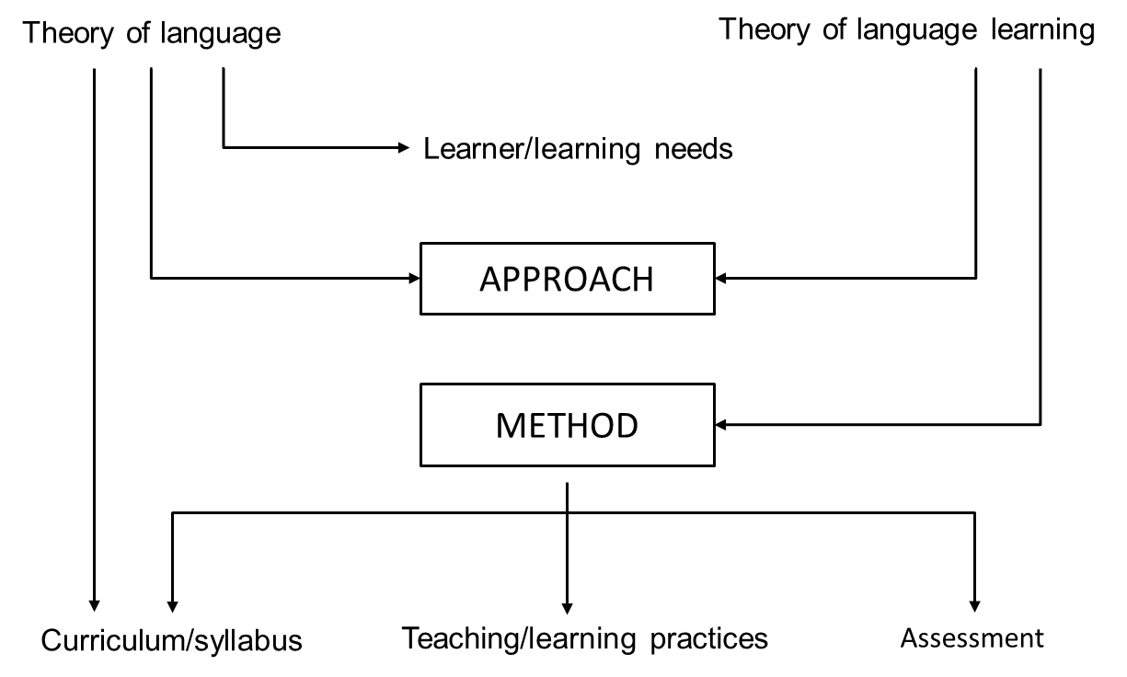
Figure 1: Foreign language didactics in the 20th century

Defining approach, method, technique
Interest in making the best possible choice of an approach or method, when planning a foreign language course, expresses the educator’s concern with effective teaching and productive learning –though there is not a single view about what ‘good’ teaching is, or what it means to have learnt something.
Task 3:
In ELT situations where it is not up to the teacher to choose the approach, method or the development of the course plan (something not at all uncommon in Greece and elsewhere), think about who is responsible for these choices [In order to answer this question, use your own experiences with regard to ELT in Greece.]
Regardless of who those planning the course are or how they plan it, the basic question asked is: What approach, what method and what techniques should be used to get ‘desirable’ results? Any attempt to respond, necessarily presupposes understanding of the terms approach, method and technique.
Task 4:
Look at the following definitions, and then decide which one describes approach and which one describes method.
- ____________: It is the overall “philosophy” –a set of ideas about what language teaching and learning should be about.
- ____________: It is a principled set of decisions as to the object of knowledge, i.e., as to what is to be taught and learnt), combined with the ways in which knowledge is to be transmitted, i.e. how what is to be learnt is dealt with.
Look at the diagram in Figure 2:
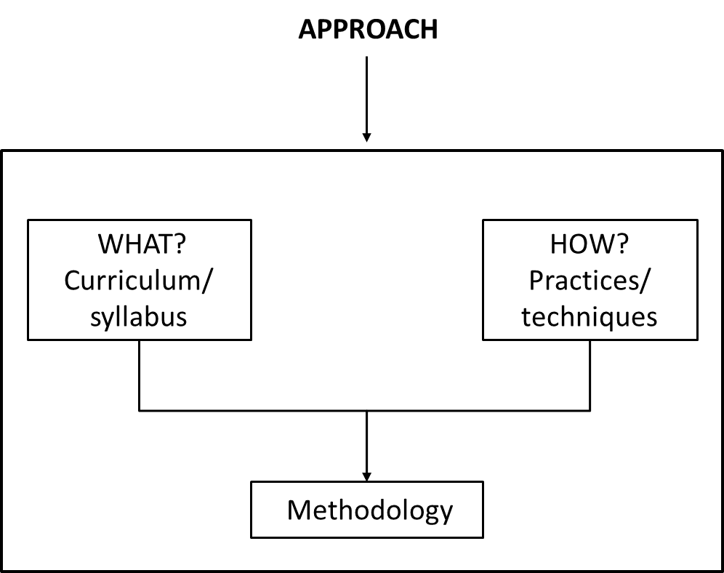
Figure 2: The relationship between approach – method.
Another way of representing the relationship between approach, method and technique is more interactive, so that a specific technique, for instance, is the starting point for a method, which stems from an approach that is developed further on the basis of the teaching/learning process results.
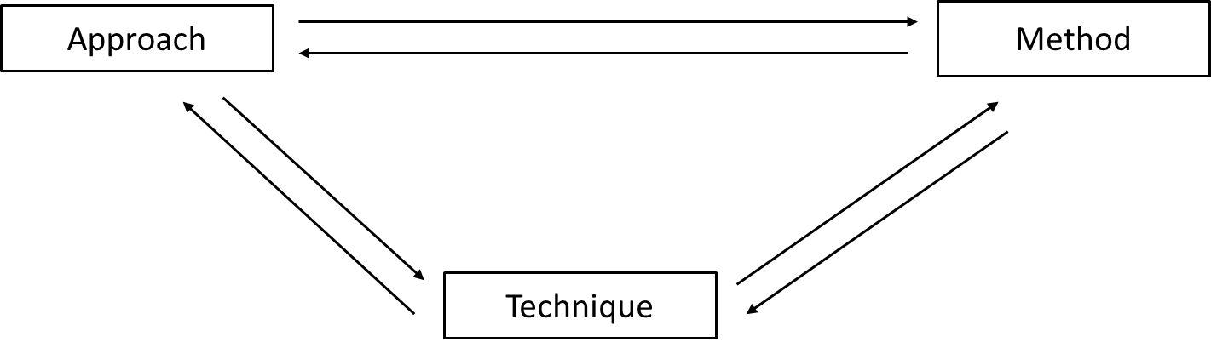
Figure 3: The relationship between approach, method and technique
There is one more distinction that must be made, and that is between the term approach and syllabus or curriculum since these are sometimes confused. For example, there are those who tend to talk about the ‘notional/functional approach’ instead of talking about a ‘communicative’ approach, which may legitimately be used to describe a set of ideas about the language learning/teaching process. ‘Notional/functional’ cannot be. Why not?
Task 5:
In order to understand why it cannot be, read the section that follows and answer why.

A historical overview of FLD approaches and methods

3.1 The birth of methodology in foreign language teaching
Before the industrial revolution, when the learning of Latin and Ancient Greek was an important part of elite education, teaching involved the transmission of knowledge about the language –the rules of prescriptive grammar– as well as practice through translation from the source to the target language and vice-versa. With the growing need for the learning of prestigious modern languages, a reform to this way of teaching began making its appearance in the 19th century. This new way of teaching foreign languages that came to be known as:

The Grammar-Translation (GT) method
It was a method in the sense that it proposed a systematic way of teaching foreign languages. Classroom teaching followed the steps below though not always in the same order.
Step 1: Each teaching unit began with the presentation of a text in the target language to be translated by students in their L1 –a text that was written to illustrate the use of the main grammar point(s) to be taught.
Step 2: Presentation by translation into L1 of all new vocabulary included in the text that students were supposed to memorize.
Step 3: Presentation of rules concerning the new grammatical phenomenon and discussed in the students’ L1 by comparing and contrasting it with the rules about the phenomenon in their own language.
Step 4: Practice of the new vocabulary and grammar through exercises (filling in, translating sentences, etc.).
Step 5: Practicing by translating, this time from L1 to L2, another text illustrating the use of the new grammar and vocabulary.
Task 6:
This method developed from the teaching of classical languages (Greek and Latin). Can you understand why?

3.2 The birth and growth of the FLD discipline
In the early nineteen hundreds, a new method was developed, partly as a reaction to the GT:

The Direct Method
The basic idea behind it was that the foreign language should be approached by way of one’s direct experience with the reality that it names and, in this sense, in some ways, it is the predecessor of the more recent Experiential Learning approaches. Its rationale was that one should learn a foreign language ‘naturally’, somewhat like one acquires his/her first language. In this sense, it shares many similarities with a language teaching approach that was proposed and developed in the 1980s by the American linguists Krashen and Terrell, known as:

The Natural Approach
Though the Direct Method found its place in the European language teaching market, the Natural Approach did not have the same reception. By that time, an important distinction was discussed in the field – i.e. the difference between second language acquisition and foreign language learning. The Natural Approach was considered more appropriate for the former. However, many of the theoretical considerations of this approach were important for the development of the field, and will be discussed separately in a future unit.
Task 7:
The terms approach and method are often used interchangeably. However, whereas the term method is commonly seen as “any principled choice of techniques for the teaching of a language (less frequently for learning), an approach is a term frequently used to when referring to the educational ‘philosophy’ or ‘theory’ of pedagogy behind the method. Bear this distinction in mind and when you finish this Unit think about whether this claim is true or false.
As the need for language learning grew in the monolingual Western countries after World War II, right around the 1950s and 60s, two new ways of foreign language teaching featured as revolutionary and were widely used in Europe –Greece included, of course:
- The Audiolingual Approach/Method
- The Audiovisual Approach/Method
These new ways of teaching were strikingly different not so much because they were based on a different view of language than the previous ones, nor because they treated the issue of use of the L1 differently than the Direct Method or the Natural Approach. Nor was it due to a new theory of learning. Like the previous reformatory methods and approaches, these new ways of teaching relied on inductive processes in learning, unlike the GT which relied on deductive learning. The difference between these and previously proposed ways of teaching and their contributions to the discipline were due to new techniques stimulated by their underlying links with Behaviourist Psychology –believing that language is a habit like any other that should be shaped and formed – and their reliance on contrastive linguistics – on the basis of which one can predict learners’ errors.
Task 8:
Look at Appendix 1A and 1B, with extracts from textbooks based on these two ways of teaching. What is one of the striking features of each?
A direct attack on behaviourism in language teaching (not just foreign language teaching) was made by empiricists but also by mentalists. Already in the 60s there was a renewed interest in the mentalist movement because of Chomskyan linguistics. Though Chomsky’s structuralist theory had only indirect implications on foreign language teaching, mentalism and the new concerns of cognitive studies had some direct effect. The relevant approach which made its appearance in foreign language didactics was:

The Cognitive Approach
Its goal was to get the language learner to understand how the language system operates so that s/he can then use it in various social situations, on the basis of his/her experience of language use.
Task 9:
Look at Appendix 2, with an extract of a textbook based on this approach and note what strikes you as very different from the ones that you looked at before.

3.3 The development of the field and its interdisciplinariness
All the methods and approaches mentioned above and the principles on which they are based, as well as the teaching techniques they have promoted have all become part of the history of the FLD and, therefore, have shaped its present where we still witness the conflict between mentalist and behaviourist views about language learning. Influential at their time, they stimulated the production of a wide range of instructional materials, teacher courses and other paraphernalia which contributed to the growth of the language teaching industry – some more than others. They are characterized by the distinct differences stimulated by the diverse views of language and language learning that informed them as they employed insights from the developing disciplines of Linguistics and Psycholinguistics.
Insights from Psychology are at the basis of a number of approaches that made their appearance in the 70s and the 80s, primarily in the U.S. Despite their promotion in language teaching and pedagogy journals and books, they were never immensely influential in Europe and did not contribute particularly to the growth of the language teaching industry, though some of their ideas and techniques have been used eclectically. These are:
- The Silent Way,
- Total physical response,
- Suggestopedia,
- Community language learning.
Claims to interdisciplinariness of the field become stronger when one considers how significant the insights from Sociolinguistics were for the birth of two new ways of foreign language teaching and learning:
- The Situational Approach,
- The Communicative Approach.
Making their appearance in Europe in the 1970s, these approaches were different from any of the previous methods and approaches to foreign language learning. They were based on an understanding of language as an autonomous meaning system and thus focused on the formal properties of language, which was the main object of knowledge. These new approaches were stimulated by the view that meaning is determined by the social context in which language is used.
The short-lived Situational Approach, whose goal was the teaching of utterances as they are used in particular social settings (i.e., at a bank, at a hotel, at a restaurant, etc.), soon gave way to the Communicative Approach (CA), which promised to produce foreign language learners that could actually use language in real life situations in ways that were not merely correct, but also appropriate for the social context for which the use of language is required. The most important innovation of the CA is its proposal that the object of knowledge in language teaching be organized not in terms of the structural elements of language but in terms of the notions and functions that are performed through language. In other words, the CA is mainly associated with a notional-functional syllabus, rather than a grammar-based syllabus – a semantic rather than a structural syllabus.
Despite various criticisms of this approach, which did not actually constitute a new teaching method – it is in fact an approach rather than a method of teaching – the CA has provided the ground on which the 21st century practices of the field are based, primarily because it shifted the focus from the language itself to how it is used in various social contexts. The natural consequence of this was a new focus of attention on the learner and his/her needs for using the language.
The CA, which will be discussed in greater detail in Unit 8, marked a return to empiricist views in language learning. Such views, along with insights from psychology and from psycholinguistic theories of interactionism, a new methodology was born in the late 80s. Concerned with procedural rather than product learning, it focused on a ‘learning-by-doing’ approach for foreign language courses. This way of teaching has come to be known as:

Task-based teaching and learning
The principles behind this way of teaching will be discussed extensively in Unit 8, like the CA, not only because both revolutionised the interdisciplinary and ‘hybrid’ field of foreign language didactics, but also because they are both still fairly extremely influential.
Task 10:
Produce a chart that shows how the different ways of thinking about language learning are enacted. Put into categories the methods and approaches that have been briefly presented to you so far.
In the late 20th century, new concerns were developed in a globalized world which is viewed as a multilingual/multicultural community. Language teaching and learning has begun being promoted as a means to developing awareness and tolerance towards cultural norms other than our own. Hence, the appearance of what has come to be known as:

The Intercultural Approach
This newer approach will also be discussed more extensively later. At this point, suffice it to say that it aims at developing language learners with intercultural awareness, rather than other-acculturated users of a dominant language.

Trend and fashion in FLD
There are some people that would readily argue that to follow new methods to foreign language teaching is like following a new trend and fashion. No matter what method is followed and despite whether a teacher is ‘good’ or ‘bad’, some people will learn and others will not. Some people would even go so far as to say that, like trend and fashion, the main purpose for new approaches and methods in education in general, language education in particular, is the production of new cultural products for greater consumerism. These arguments are not of course totally invalid given the fact that foreign language teaching is a big market and every time a new approach or method makes its appearance, the new cultural artifacts are produced (teacher materials and package-deal courses, textbooks and other kinds of instructional materials as well as assessment tools), boosting the language teaching industry. “The rise and fall of methods is due mainly to the influence of profit seekers, promoters and forces of the intellectual marketplace” Richards (1989) claims.
Task 11:
Look at a list of statements below, which are informed by politicized views of foreign language didactics and decide whether you can think of any additional arguments to the same effect.
- Basic elements of methods considered as totally new and exciting or others that totally overturn ways of thinking have been around for hundreds of years. In essence methods represent different configurations of the same basic options.
- Trend and fashion in methods and approaches or why some become more widespread and popular than others, is due to a variety of factors which have little to do with the quality of the method itself.
- While new methods and approaches of teaching and learning a language have often been viewed and promoted as a better way of teaching and learning a language, very little or no serious and systematic, longitudinal research is ever carried out to provide proof as to the effectiveness of one method over another.
- The few comparative studies of methods that have been carried out have been unable to reach any definite conclusions as to whether one method is superior to any other.
- Methods for language teaching and learning are not always theoretically well informed. Most often, they comprise language teaching recipes ready for consumption by theoretically uninformed and ill prepared language teachers.
- Methods are usually developed in the West and have everything to do with the cultural politics of language of countries such as the U.S., England, France and Germany.
- New methods and approaches (which are produced in the intellectual marketplace of dominant countries in order to be exported) are always presented as advanced and effective, regardless of the specific educational, social and cultural contexts of the users of these products or their values and beliefs.
There is, however, another line of argument (Dendrinos 1992), which is not politically uninformed. The argument focuses around the claim that different approaches to teaching and learning provide the ground for different pedagogic and social practices that contribute differently to the development the social identity of the learner as well as to the construal of a different learner identity.

References
Richards J.C. (1988). The Language Teaching Matrix. Cambridge University Press.
Dendrinos, B. (1992). The EFL Textbook and Ideology. Athens: N.C. Grivas Publications.

Appendix 1A
Asking about Likes and Dislikes
691 What is it you don't like about winter weather?
692 I don't like it when the weather gets real cold.
693 I can't stand summer weather.
694 The thing I don't like about driving is all the traffic on the road.
695 He doesn't like the idea of going to bed early.
696 I like to play tennis, but I'm not a very good player.
697 I don't like spinach even though I know it's good for me.
698 I'm afraid you're being too particular about your food.
699 He always finds fault with everything.
700 She doesn't like anything I do or say.
701 You have wonderful taste in clothes.
702 What’s your favorite pastime?
703 What did you like best about the movie?
704 I didn't like the taste of the medicine, but I took it anyway.
705 Why do you dislike the medicine so much?

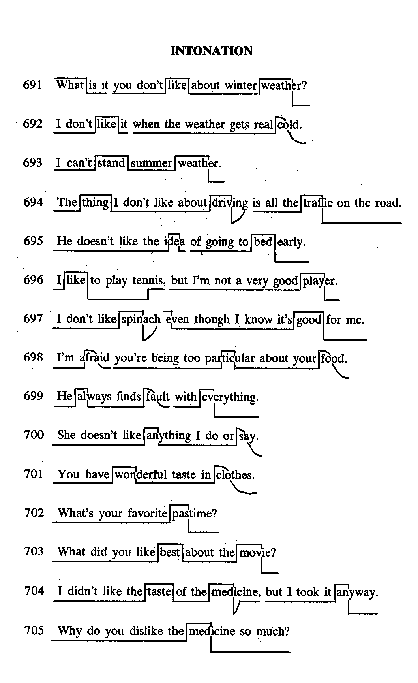
Verb study
1. can't stand, couldn't stand (something or somebody)
- I can't stand summer weather.
- If you can't stand summer weather, why don't you go north?
- She can't stand the winter, and she is miserable in summer.
- She couldn't stand me, and I couldn't stand her.
2. play
- I like to play tennis, but I'm not a very good player.
- He played baseball all afternoon yesterday.
- I have a friend who plays chess.
- Have you ever played tennis with Mr. Cooper?
- We're playing bridge right now. We'll be finished in an hour.
3. find fault (with)
- He always finds fault with everything.
- Did he find fault with anything you said?
- He found fault with everything I did.
- I've never found fault with anything you've ever done.
4. dislike
- Why do you dislike the medicine so much?
- You don't dislike John, do you?
- He doesn't really dislike you, does he?
- I don't know why I dislike spinach.
5. like (best or best of all)
- What did you like best about the movie?
- Of all the movies you saw last year, which did you like best?
- Did you like your language teacher best of all?
- What did he like best about the restaurant?
6. object (to)
- Why do you object to cleaning the house?
- He always objects to taking his medicine,
- The lawyer objected to the decision.
- I've never objected to winter weather.
Examples of Substitution Drills

1. What is it you
don't like
particularly dislike
especially don't like
hate
like so much
find so attractive
about whiter weather?

2. I don't like it when the weather gets
real
very
really
unusually
uncomfortably
terribly
miserably
cold

Appendix 1B
Lesson 43
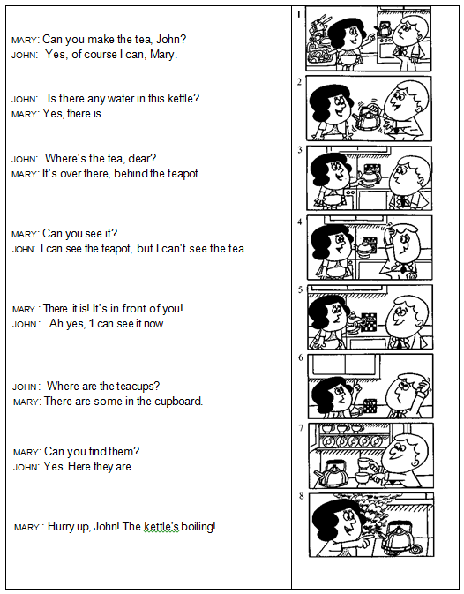

Lesson 44
Is there any…? Are there any…?
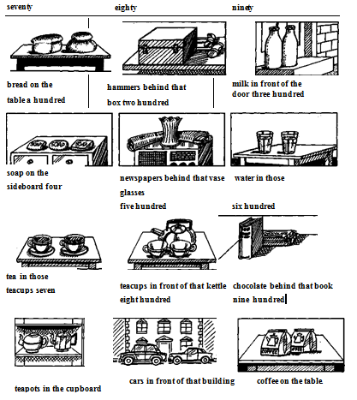
Exercise
Look at these:
glass - glasses; book - books; housewife - housewives.
Now look at this:
I can see some cups, but I can't see any . . . (glass).
I can see some cups, but I can’t see any glasses.
Do these in the same way:
I can see some spoons, but I can't see any . . . (knife).
I can see some hammers, but I can't see any . . . (box).
I can see some coffee, but I can't see any . . . (loaf) of bread.
I can see some cupboards, but I can't see any . . . (shelf).
I can see Mr Jones and Mr Brown, but I can't see their wife.
I can see some cups, but I can't see any . . . (dish).
I can see some cars, but I can't see any . . . (bus).

Appendix 2
Lesson 43
Comprehension and Précis
Answer these questions in not more than 80 words.
- Is Geoffrey Hampden greatly admired for his fine sense of humour or not? What was he invited to do? Did he immediately agree to do so or not? (When Geoffrey . . . who is. . .)
- Did the speech contain a lot of funny stories or not? Was it a great success or not? (Since]
- What did his six-year-old daughter, Jenny, want to do after his speech? Was Geoffrey disappointed or not? (When)
- Why had she not enjoyed it? (because]
Composition
Write two or three sentences using the ideas given below:
Geoffrey was amused by Jenny's answer—he explained why everybody laughed— there was another reception some time later—Geoffrey made a speech—not very funny —Jenny asked why no one laughed.
Letter-writing
Learn the following opening phrases by heart: You must be very annoyed with me for . . . I have just heard that...
Exercise
Write two short paragraphs (of not more than two sentences each) completing the above phrases.
Key Structures
He said that... He told me ... He asked . . . (KS 41, 99)
Study these sentences carefully:
'Open the door for me please,' she said to me.
What did she ask me to do?
She asked me to open the door for her.
Now compare these pairs of sentences:
b. He had already finished work before I arrived.
He had been working in a factory for years before he got this job.
I asked him what he had lost.
I asked him what he had been doing all afternoon.
Exercises
- Underline the verbs in the passage which tell us what had happened and what had he en happening,
- Give the correct form of the verbs in brackets. Do not refer to the passage until you finish the exercise:
- Firemen (fight) the forest fire for nearly three weeks before they could get it under control. A short time before, great trees (cover) the countryside for miles around.
- The planes (plant) seed for nearly a month when it began to rain. However, by then in many places the grass already (take) root. In place of the .great trees which (grow) there for centuries, patches of green (begin) to appear in the blackened soil.
- What happened? What had happened? What had been happening? Give the correct form of the verbs in brackets: After Howard Carter (discover) Tutankhamen's tomb, strange reports (appear) in the newspapers. Three of the people who (take) part in the discovery (die) soon afterwards. Though nothing (happen) to Carter himself, newspapers (claim) that these people (die) because of the 'curse of the Pharaohs'. These absurd stories have been forgotten, but Carter's great discovery remains. Archaeologists (search) the Valley of Kings for years, but until 1922 nothing (find).
Special Difficulties
Words Often Confused.
- Control (1.3) and Check. Study these examples:
  - He controls a large business company.
  - A mechanic checked my car engine.
- b. Great (1.4) and Big. Study these examples:
  - The Parthenon is a great building. (An important building.)
  - Skyscrapers are big buildings.
- Soil (1. 10) and Ground (1. 6).
  - Olive trees can grow in poor soil.
  - The ball fell to the ground.
Exercise
Choose the correct words in the following sentences:
- The inspector (checked) (controlled) my ticket.
- Nothing can grow in this poor (soil) (ground).
- Have you (checked) (controlled) those figures?
- Beethoven was a (big) (great) composer.

Notes
Note on History of Published Versions:
The present work is the edition 1.0.
Reference Note:
Copyright National and Kapodistrian University of Athens, Bessie Dendrinos. Bessie Dendrinos. “Applied Linguistics to Foreign Language Teaching and Learning. Approaches and Methods for Foreign Language Teaching”. Edition: 1.0. Athens 2014. Available at: http://opencourses.uoa.gr/courses/ENL6/.
Licensing Note:
The current material is available under the Creative Commons Attribution-NonCommercial-ShareAlike 4.0 International license or later International Edition. The individual works of third parties are excluded, e.g. photographs, diagrams etc. They are contained therein and covered under their conditions of use in the section «Use of Third Parties Work Note».
[1] http://creativecommons.org/licenses/by-nc-sa/4.0/
As Non-Commercial is defined the use that:
- Does not involve direct or indirect financial benefits from the use of the work for the distributor of the work and the license holder.
- Does not include financial transaction as a condition for the use or access to the work.
- Does not confer to the distributor and license holder of the work indirect financial benefit (e.g. advertisements) from the viewing of the work on website.
The copyright holder may give to the license holder a separate license to use the work for commercial use, if requested.
Preservation Notices:
Any reproduction or adaptation of the material should include:
- the Reference Note,
- the Licensing Note,
- the declaration of Notices Preservation,
- the Use of Third Parties Work Note (if available),
together with the accompanied URLs.

Financing
- The present educational material has been developed as part of the educational work of the instructor.
- The project “Open Academic Courses of the University of Athens” has only financed the reform of the educational material.
- The project is implemented under the operational program “Education and Lifelong Learning” and funded by the European Union (European Social Fund) and National Resources.

